**Online Diary – Client Meeting**

Team Members – Connor Winspur, Brennon Franklin, Danyal Mahmood.

Clients – Saira Mahmood, Reece Taylor, Ben Miller.

**6.0 – Overview**

The task the team was set with was to meet with a group of clients, interviewing them to find out what type of game they wanted to be created and the requirements and limits the project would have. From this interview the group had to create a game idea that matched the information gathered from the interview and to present this idea back to clients for their approval.

**6.1 – The Game Idea**

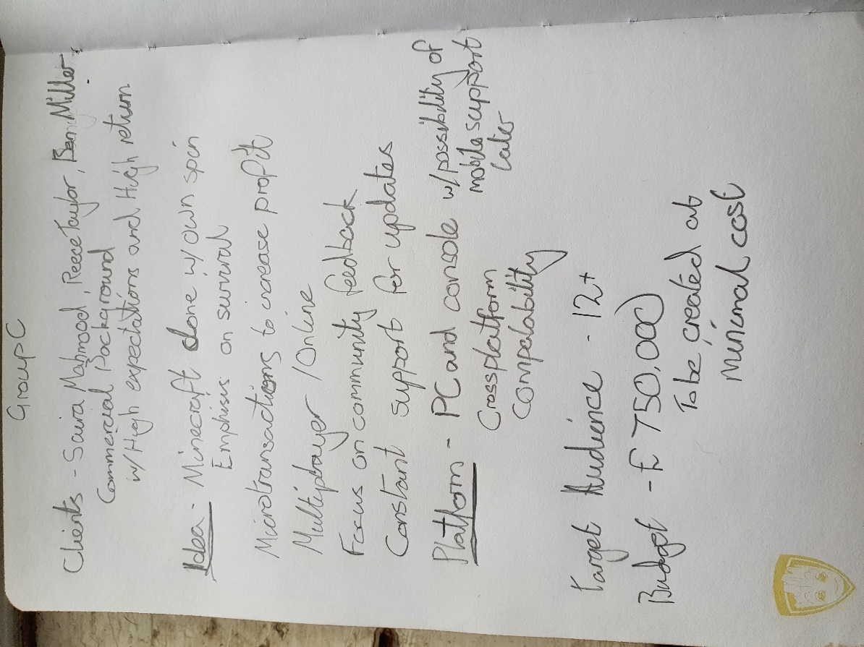

Figure 6.1 – Interview Notes

This figure displays the notes taken during the interview with the clients, gathering the requirement for the game the clients wanted to be created.

The game idea the team came up with was a game named BlockCraft 3D. The game would be open source under the LGPL, and written primarily in C++. With the main focus being development for PC and console audiences with the possibility of a mobile version down the line. The team would stay on the development of the program long term in order to develop the product further.

BlockCraft 3D would be a full-featured game that focuses on survival of the player, allowing them to utilize the resources surrounding them and to explore an open world environment, complete with multiplayer and a number of add-on modules installed by default to let you try out different gameplay mechanics. With these add-ons being either free to use or cost a small amount to purchase.

It was also decided to implement a battle pass system named ‘Craft Pass’ along with an in-game store. The use of this battle pass will enable players to continue returning to the game to check out new content, while providing access to all the add-ons available in the game. The in-game store will also include different bundles that players can purchase that will provide exclusive items and advance the players progress on the battle pass.

**6.2 – The Interview Process**

During the interview the team decided to initially learn what game the clients wanted to be designed and what their goals for this game were. This allowed our group to establish what direction the clients wanted the game to go and what features they were expecting. Following this the team decided to learn what area of the market they wanted to target, both the age of the audience and the platform the game will be released onto. Next was learning the budget and what the clients expected that budget to be spent on, with the final area of questioning being focused on learning what the clients were like and the expectations they had for the team.

**6.3 – Feedback and Improvements**

The clients decided to commission the project after the presentation, however from the feedback provided the game itself followed the brief quite closely, however in the interview and presentation, the team did not provide both the cost it was going to take to develop the game and the time the clients wanted the game built in or alternatively how long it would take to develop. In the future the group should focus on a more structured approach to the interview, allowing all the information required to create a game idea to gathered in a clear manner. While also probing deeper into what the client expects form the game and what they want included.